How to Take Political Nurse Constituent Action!

Locate your Illinois state officials to ask them to vote on health policy!

Locate your state Senator & state House Representative. They represent your constituent issues in your state legislative District. These legislators are in the Illinois General Assembly, vote on state laws in our Capitol in Springfield, IL. State officials have offices locally in your District and an office in Springfield, IL. The General Assembly members vote on all state legislation. Nursing regulation such as the Illinois Nurse Practice Act is state regulation. Chicago Aldermen do not vote on state regulatory issues.

Type in Search engine (Google, Firefox) this link:
https://www.illinoispolicy.org/maps/ to arrive at this page

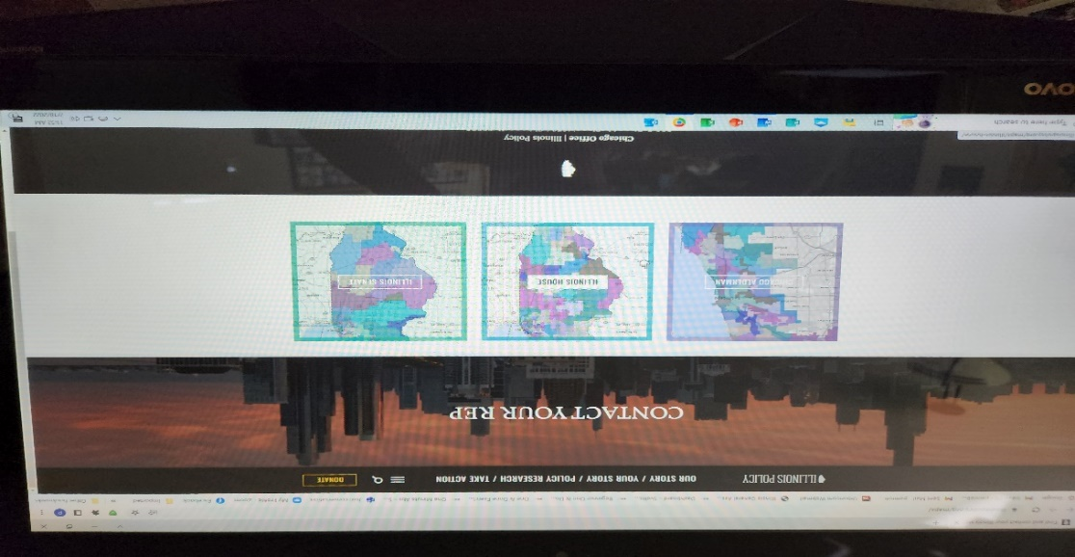

Click on “Illinois House”, “Illinois Senate” or “Chicago Alderman” box - open each window one at a time and
enter your home address for each box.
Discover your elected official’s contact information so you can inform them how to vote on a particular issue.

